Create 20 files with .txt extensions and rename the first 5 files to .yml extension Print the latest created top 5 files among the total no of files

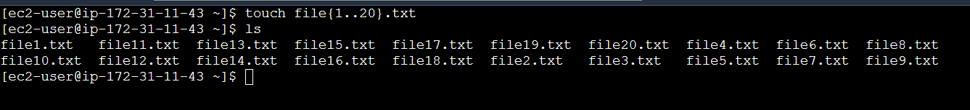

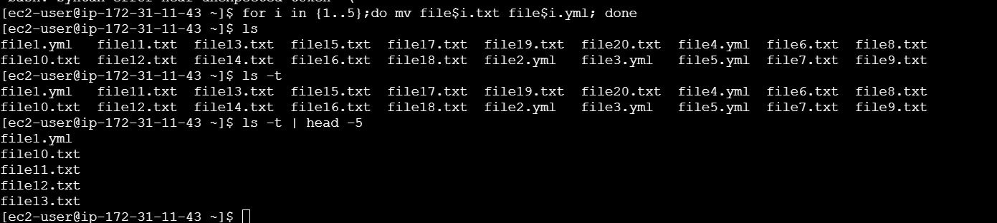

Touch file {1..20}.txt creates 20 files named file1.txt, file2.txt,…,file20.txt

For I in {1..5}; do mv file$i.txt file$i.yml;done renames the first 5 files (file1.txt to file5.txt) to file1.yml, file2.yml,…file5.yml

Ls -t lists the files in the current directory in the order of their last modification time (latest first)

Head -5 displays only the top 5 files from the list